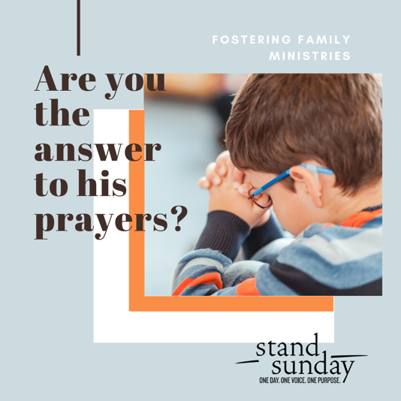

Stand Sunday Community Event
Nov. 8, 2020
(safety protocols in person or join by live stream)

Prayerfully choose the level of impact you make in
the lives of hundreds of children in our communities
in foster care. Be inspired by the testimony of foster, kinship & church family portraits.

Sponsorship Levels
(one-time gift or 12 mos. subscription)

Champion Over $10,000 to $7,100
4 tickets VIP reception & reserved seating, Champion ad

Platinum $7,000 to $5,100
4 tickets VIP reception & reserved seating, Platinum ad

Diamond $5,000 to $2,500
4 tickets VIP reception & reserved seating, Diamond ad

Gold $2,500 to $1,100
2 tickets VIP reception & reserved seating, Gold ad

Silver $1,000 to $510
2 tickets VIP reception & reserved seating, Silver ad

Bronze $500 to $100
2 tickets VIP reception & reserved seating, Bronze ad

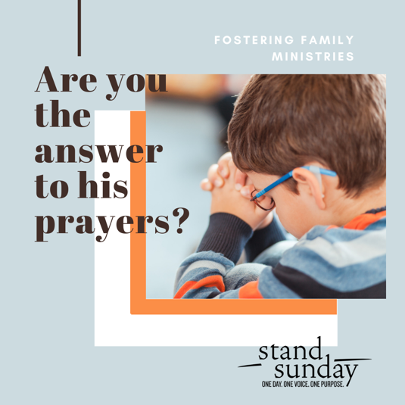

Stand Sunday Community Event
Nov. 8, 2020
(safety protocols in person or join by live stream)

Prayerfully choose the level of impact you make in
the lives of hundreds of children in our communities
in foster care. Be inspired by the testimony of foster, kinship & church family portraits.

Sponsorship Levels
(one-time gift or 12 mos. subscription)

Champion Over $10,000 to $7,100
4 tickets VIP reception & reserved seating, Champion ad

Platinum $7,000 to $5,100
4 tickets VIP reception & reserved seating, Platinum ad

Diamond $5,000 to $2,500
4 tickets VIP reception & reserved seating, Diamond ad

Gold $2,500 to $1,100
2 tickets VIP reception & reserved seating, Gold ad

Silver $1,000 to $510
2 tickets VIP reception & reserved seating, Silver ad

Bronze $500 to $100
2 tickets VIP reception & reserved seating, Bronze ad

Stand Sunday Community Event
Nov. 8, 2020
(safety protocols in person or join by live stream)

Prayerfully choose the level of impact you make in
the lives of hundreds of children in our communities
in foster care. Be inspired by the testimony of foster, kinship & church family portraits.

Sponsorship Levels
(one-time gift or 12 mos. subscription)

Champion Over $10,000 to $7,100
4 tickets VIP reception & reserved seating, Champion ad

Platinum $7,000 to $5,100
4 tickets VIP reception & reserved seating, Platinum ad

Diamond $5,000 to $2,500
4 tickets VIP reception & reserved seating, Diamond ad

Gold $2,500 to $1,100
2 tickets VIP reception & reserved seating, Gold ad

Silver $1,000 to $510
2 tickets VIP reception & reserved seating, Silver ad

Bronze $500 to $100
2 tickets VIP reception & reserved seating, Bronze ad

